Game Design Document (GDD)

This document is the project write up for the Udacity TeamWork project. It contains a description of the main components of the game such as the idea, the game mechanics and scripting and the artwork.

# Contents:

Contents:

Description of the Game:

General

Gameplay and Objectives

Levels/Scenes Description

The Environment

The Player Character

Game Mechanics

Prototyping

Class/Object Design

Art work

Scene Composition & GUI

Skyboxes

3D models & prefabs

Animations

Particle systems

Musical theme

Sound Design

# Description of the Game:

## General

Name of the game: Color Blast

Target platform: Google Cardboard for Android or iOS

Genre: First Person Shooter / Match 3 game

Developer: Team Matrix

## Gameplay and Objectives

Please note that not all intended game features described in this paragraph were implemented in this project.

This game is intended to be a first person shooter in VR in which the player will target colored shapes with a colored weapon.

The player stands at the center of an arena of a cylindrical shape.

The targets are colored spheres distributed horizontally in a circular shape and vertically in 3 similar layers.

The weapon’s color should match the target’s color to increase the player’s score otherwise a penalty is applied.

The weapon changes color randomly after each successful shot.

At any time if there are three targets with matching colors horizontally, vertically or diagonally the targets are destroyed and the player’s score is increased.

A spawn portal should be present in order to replace the destroyed targets with new ones.

Winning/Leveling up condition would be to attain or exceed a certain target score with less shots than the allowed number of shots.

Losing condition would be when failing to attain the target score with the allowed number of shots (just like candy crush game).

## Levels/Scenes Description

The game consists of 2 scenes or screens:

1. The start scene: containing a start button that leads to the instructions scene.
2. The gameplay scene: showing the arena, targets, spawn portal...

## The Environment

The game takes place in a mountainous setting.

## The Player Character

It’s a first person shooter game.

# Game Mechanics

## Prototyping

Prototyping would be performed with generic 3D shapes such as sphere, cubes, planes, etc... The focus would be on the game play mechanics and the generic shapes would be later replaced by more elaborate 3D models.

## Class/Object Design

In addition to the GVR scripts that were used for the VR camera and the interaction with objects in the scene, the following classes were used for the implementation of the game’s idea:

**GvrEditorEmulator**

This game object includes an emulator for the VR camera and for the Reticle pointer which interacts with objects in the scene.

**ChangeScene**

This script loads the gameplay scene when the user taps on start in the start scene.

**Target prefab**

A prefab that rotates around the center of the arena and stops it a collider is detected. Attached to this prefab are the TargetRotator, the RayCaster and the Destroyer which are described later.

**LevelGenerator**

A script that instantiates the target spheres given a certain spacing from a previously instantiated target prefab with random color assignment the spheres are considered as gameobject prefabs with the name “Target0”, “Target1” and “Target2”.

**TargetRotator**

This script is attached to the “Target” prefabs and causes them to rotate around the center of the arena with a rotation speed that could be defined by the user.

**RayCaster**

This script is attached to the “Target” prefabs and causes them to stop the rotation if a collider is detected within a certain distance.

**Portal gameobject**

A game object that is used as a collider which stops the rotation of the target spheres.

**Destroyer**

A script attached to the target prefab that destroys the prefab in the scene when targeted by the GvrEmulator.

# Art work

## Scene Composition & GUI

**Start Scene:**

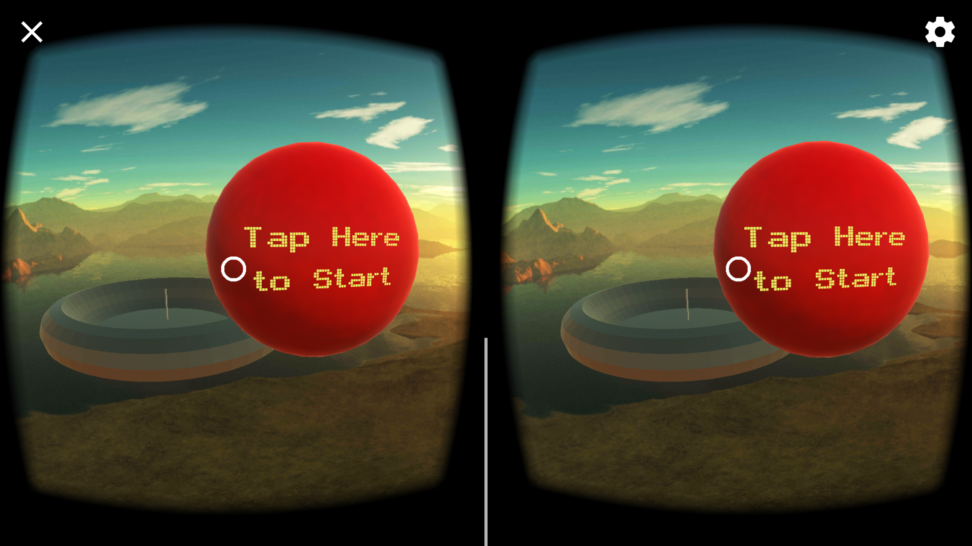

**GamePlay Scene:**

In this VR game, the point of view would be at the center of the arena.

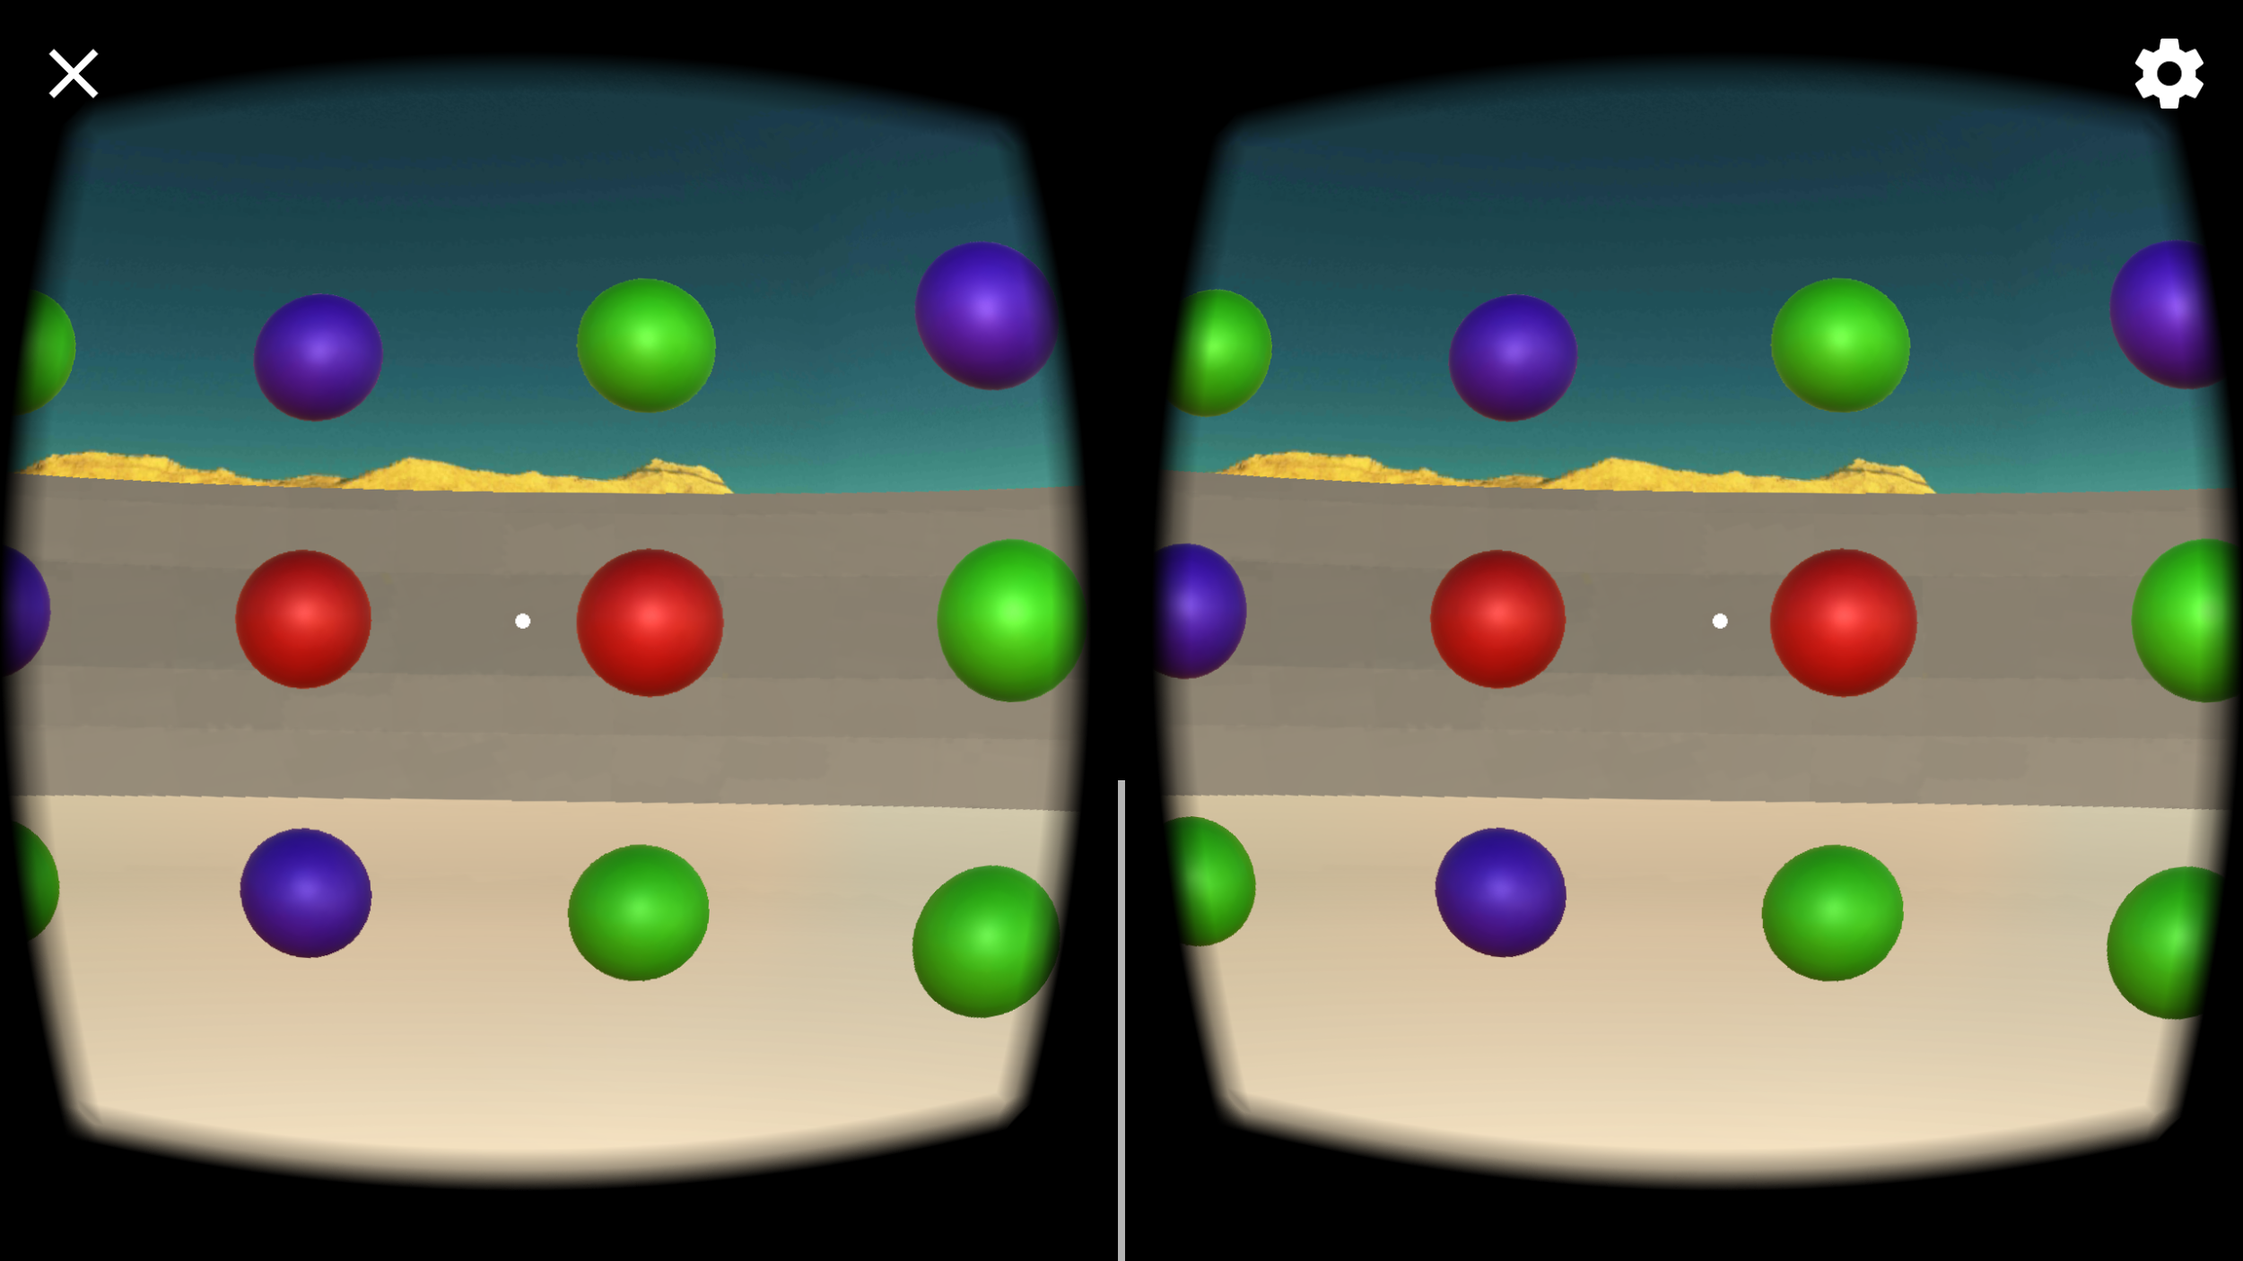

## **Skyboxes**

The skybox used is shown in the following figure.

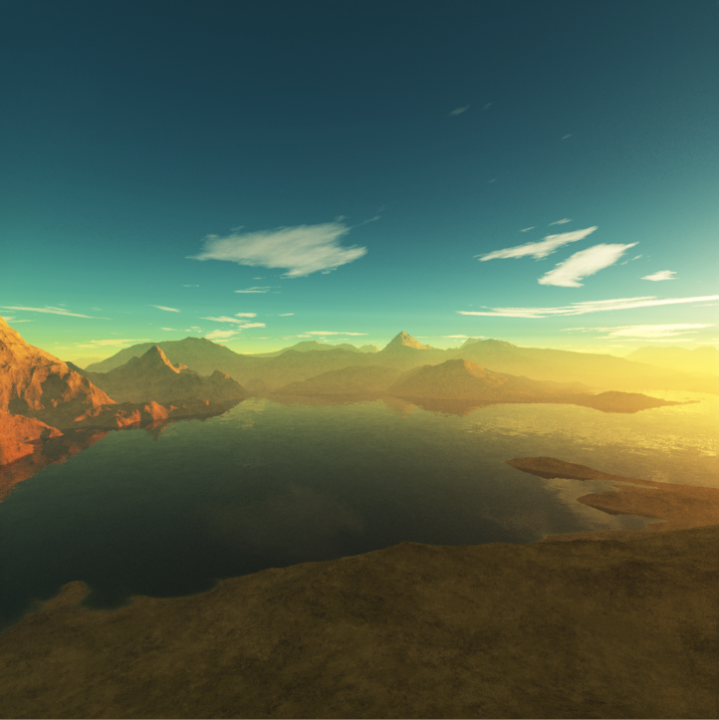

## 3D **models** & prefabs

The scene is simple consisting of an arena with the targets prefabs and the portal collider as shown in the following figure.

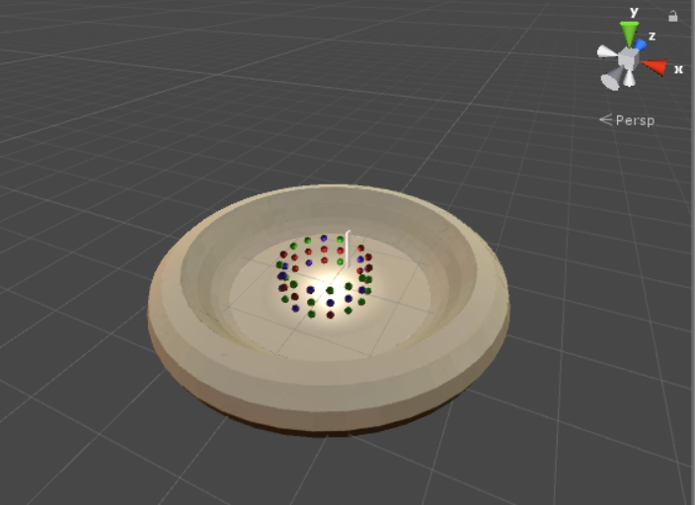

## **Animations**

The targets’ rotation around the center of the arena are scripted.

Mecanim was used for the animation of the floating arena in the start scene.

## Particle **systems**

Not used.

## Musical **theme**

Not used.

## Sound **Design**

Not used.